**EOG based simple game interface**

**(SC_9)**

|  |  |  |
| --- | --- | --- |
| Name | ID | Level |
| Sarah Adel ElGebaly Mohammed | 20191700274 | 4 |
| Ehab Mohammed Abdelmonem Mohammed | 20191700168 | 3 |
| Menna-t-Allah Wael Saed Abdelwhab | 20191700688 | 3 |
| Nada Mohammed Taalab AbdAllah | 20191700686 | 3 |

* **Data Preparations and Preprocessing**
* Changed the Turkish labels to meaningful labels:

Yukari u

Asagi d

Sag r

Sol l

Kirp b

* Created a data frame consisting of 3 columns:

1. Horizontal signal
2. Vertical signal
3. Direction of movements

* Filtered the signals by Butterworth band pass filter (from 1 to 25 Hz) with sampling frequency 176.
* Resample the signal to 60 samples.
* Removed DC component by removing the mean value from each signal.
* Normalized signals values.

**Some signal before preprocessing**

**Some signal after preprocessing**

* **Features Extractions**

1. Wavelet coefficients by applying wavelet transform algorithms (3 Levels).
2. Morphology Features:

* Max Peaks
* Area under the curve

1. Power Spectral Density (PSD)

* **Classifiers**

We divided the data into 75% train and 25% test.

We tried a lot of Classifiers with different parameter, but the default parameters showed the best results, here are some of the used classifiers:

1. AdaBoost
2. Support Vector Machine (SVM)
3. Gradient Boosting
4. Random Forest
5. Extra Trees
6. Voting (with Random Forest and Extra Trees as estimators)

* **Classifications Results**

|  |  |
| --- | --- |
| **Classifier** | **Accuracy** |
| AdaBoost | 36% |
| SVM | 64% |
| Gradient Boosting | 68% |
| Random Forest | 100% |
| Extra Trees | 100% |
| Voting | 100% |

**The Game (Delivery Man)**

A simple game about a delivery man in a small town, he always has random deliveries to deliver, each delivery has its destination on it, his mission is to keep delivering the right deliveries to the right places to gain as much cash as possible, he must avoid obstacles in order to reach his destination without getting lost.

First it Generates the world obstacles in a random way:

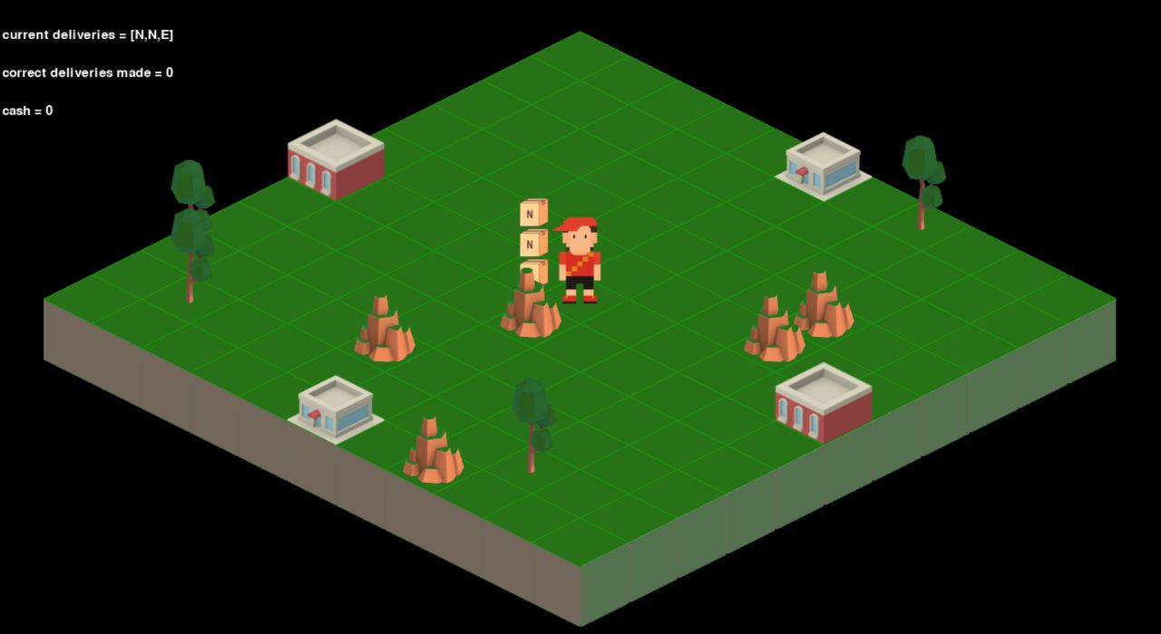

In a Different Run

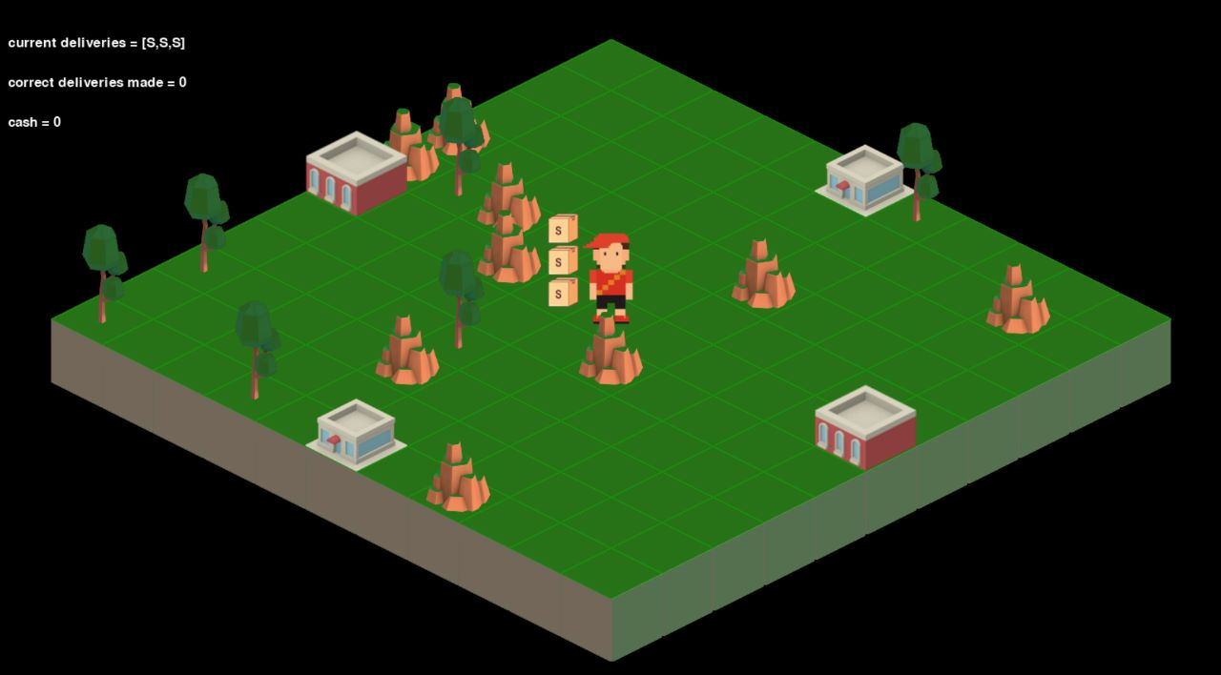

In the game the delivery man should deliver the box to the right house to earn money:

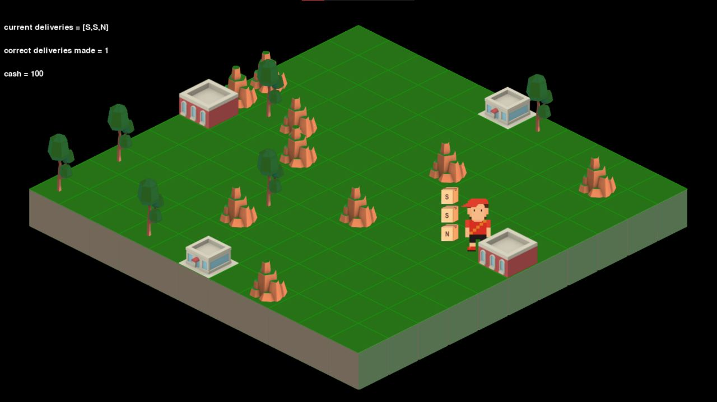

If he made a wrong delivery, he would lose money:

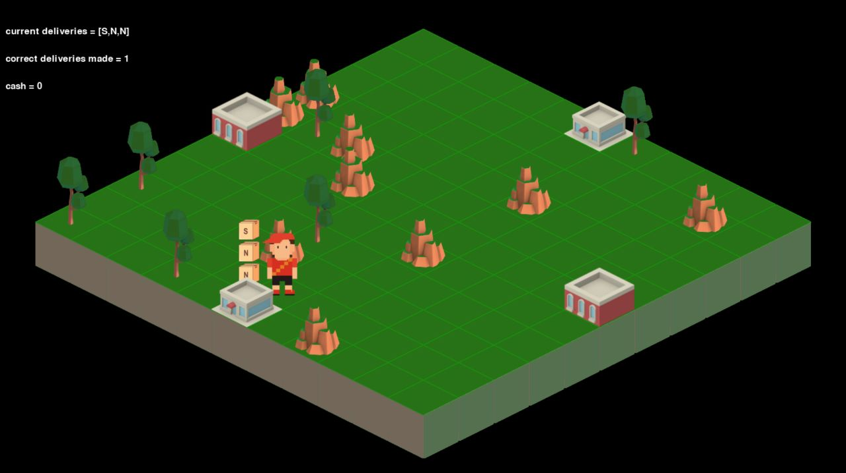

After some right deliveries while playing:

